Users login through Salesforce (Communities page) – DSS has a portal with multiple apps

Communities expose internal Salesforce data to an external group of users

Apps in our DSS portal can be accessed by searching in Salesforce

Other areas have different portals

Environments (orgs)

Sandboxes – do development here. train users before prod. Each developer takes a sandbox

Venus (Dev 1)–

Mercury (Dev 2) –

SIT – where developer testing occurs. Deploy from sandbox

UAT - where user acceptance testing occurs

Production –

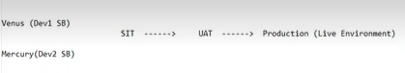

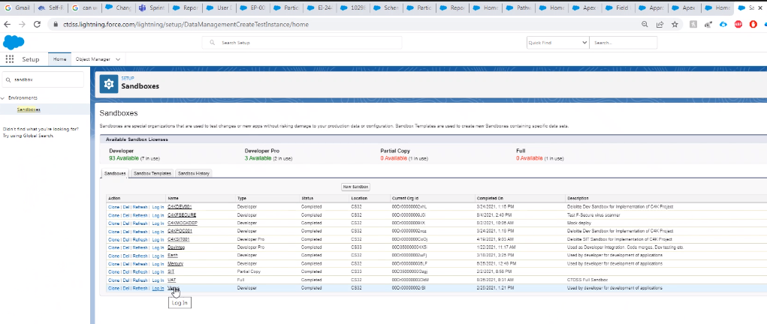

Migration Process:

Use Change sets to move from 1 org to another org

Release artifact is a set of metadata changes

Change sets can’t include deleted items????

Would you have to keep track and delete manually???

* [Change Set Development](https://trailhead.salesforce.com/en/modules/declarative-change-set-development)
* [Org Development](https://trailhead.salesforce.com/content/learn/modules/org-development-model)
* [Package Development](https://trailhead.salesforce.com/en/trails/sfdx_get_started/modules/sfdx_dev_model)
* [Unlocked Packages for Customers](https://trailhead.salesforce.com/en/modules/unlocked-packages-for-customers) (module)
* [Quick Start: Unlocked Packages](https://trailhead.salesforce.com/en/projects/quick-start-unlocked-packages) (project)
* [Salesforce DX Developer Guide](https://developer.salesforce.com/docs/atlas.en-us.224.0.sfdx_dev.meta/sfdx_dev/sfdx_dev_intro.htm)
* [Get Started with Salesforce DX](https://trailhead.salesforce.com/trails/sfdx_get_started) (trail)

**Pathways – multiple modules**

Objects

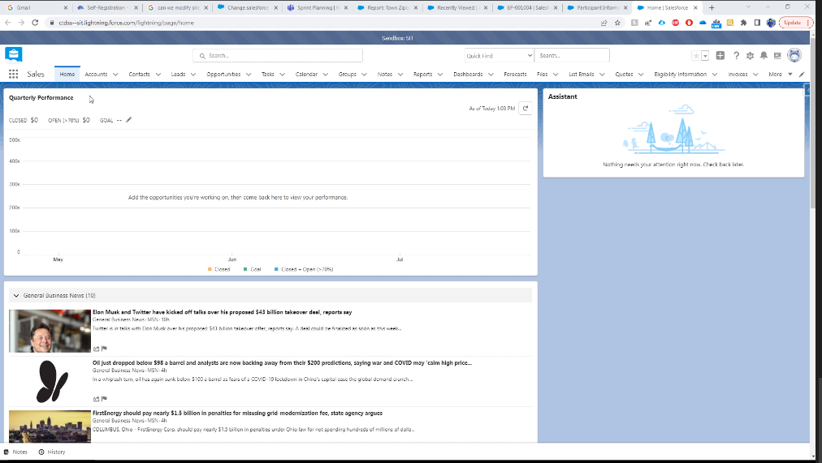

Schema Builder to see the sctucture. Most of these are not used

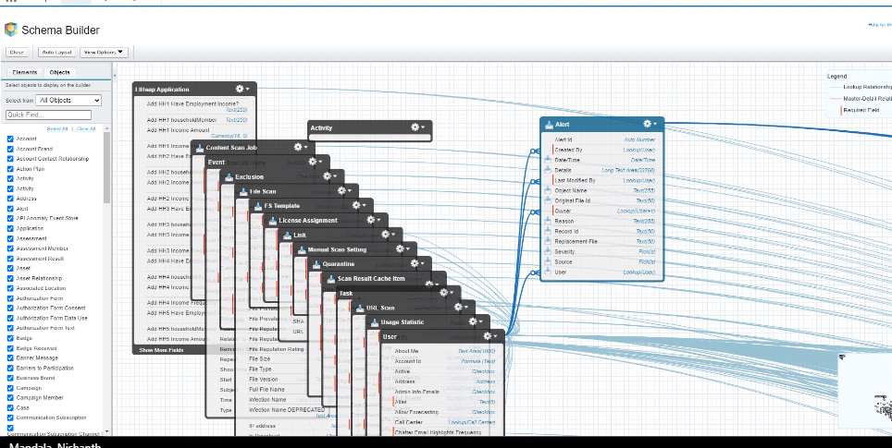

We use :

Account

Contact

Eligibility

Pathways:

Low income customer

Need skills to be a healthcare worker

Enroll in pathways employment training

Eligibility criteria to enroll in community college or other training certificates – determined in Impact, we just get a feed

Account – providing the training service

Ex: Community college

Contact

Customers (Participant)

College coordinator

Eligibility

Months

Coordinator can only enroll the customer if eligible for a month (on the table)

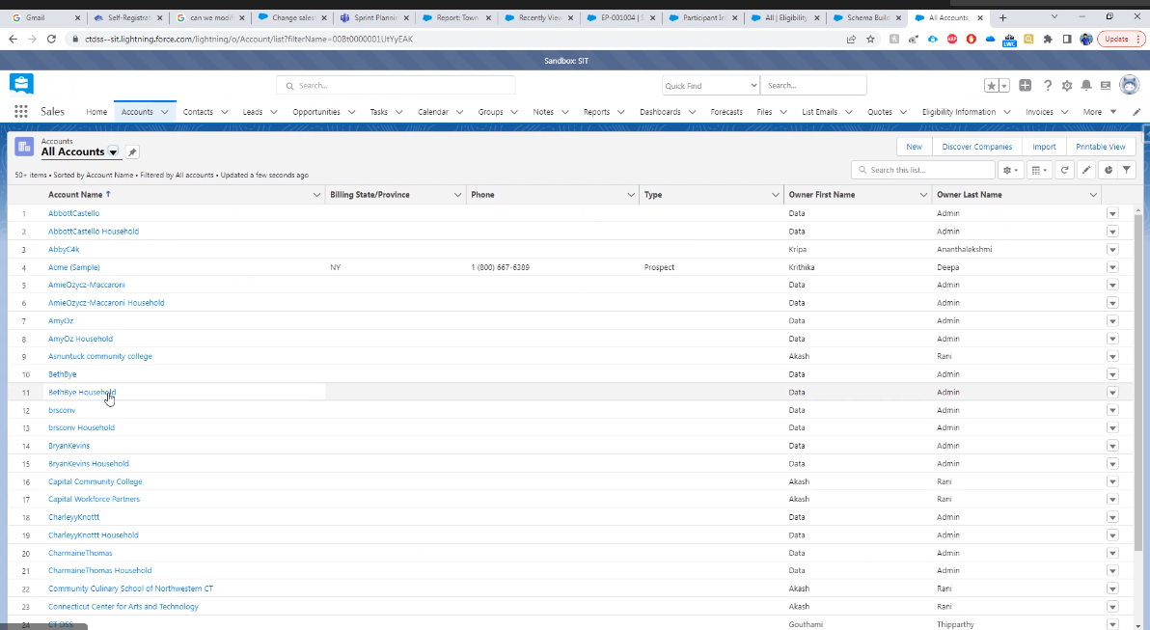

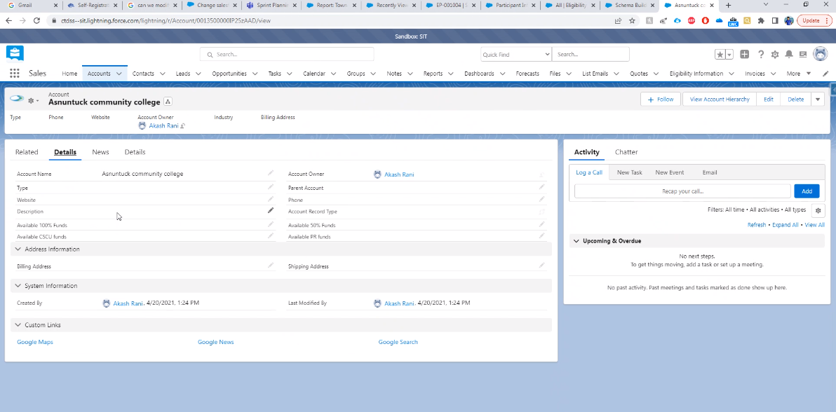

Account data is entered by the User

Sample Contacts:

Coordinator works for the college

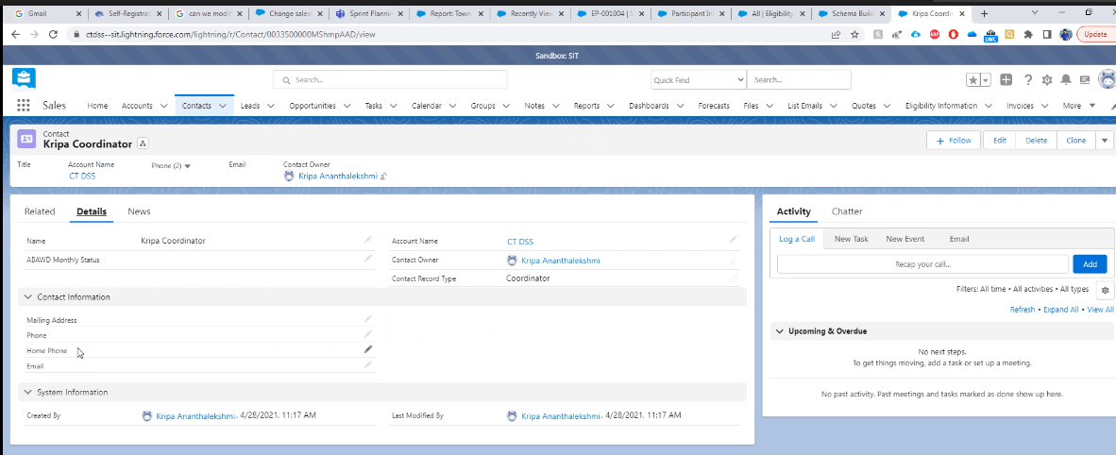

This is a Student Contact

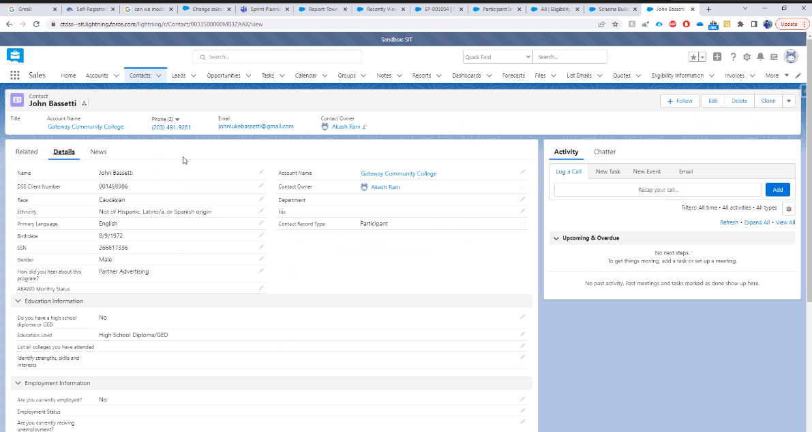

Eligibility loaded from a batch job

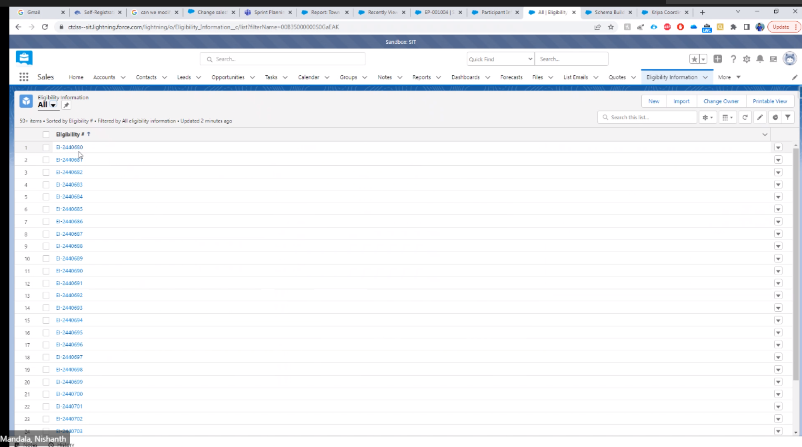

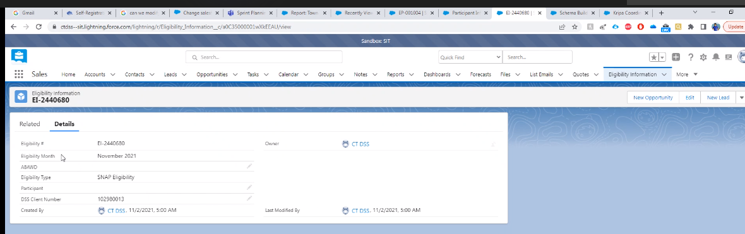

DSS Client Number is unique to each participant

Communities – external website where participant is entered and they determine eligibility

Search on Pathways to get there

Or

Impersonation:

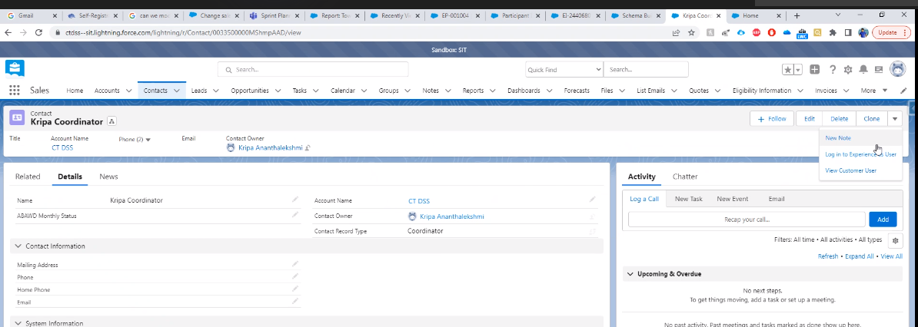

Pathways:

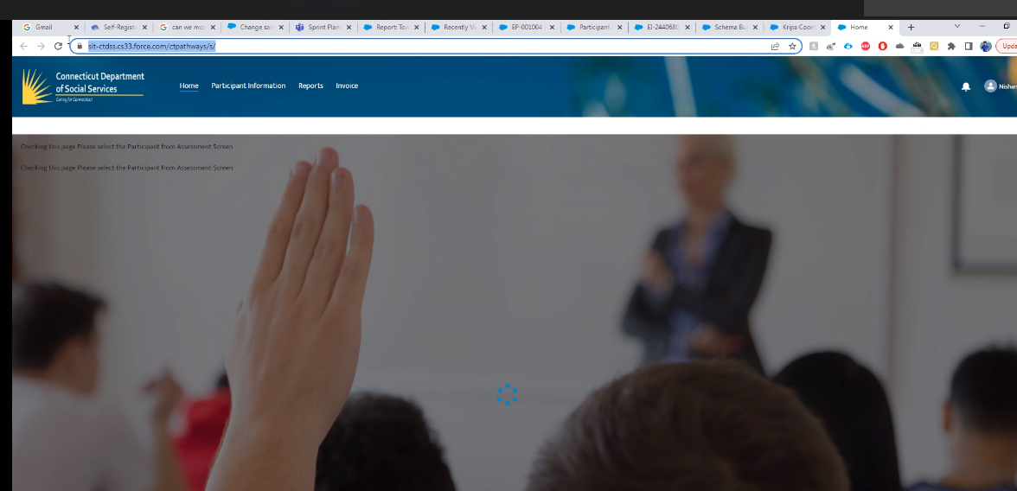

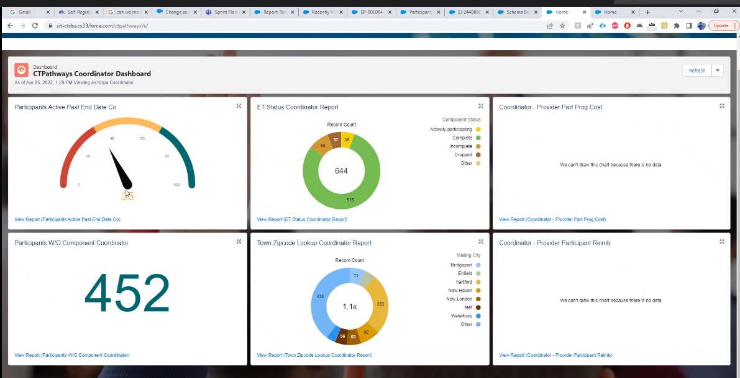

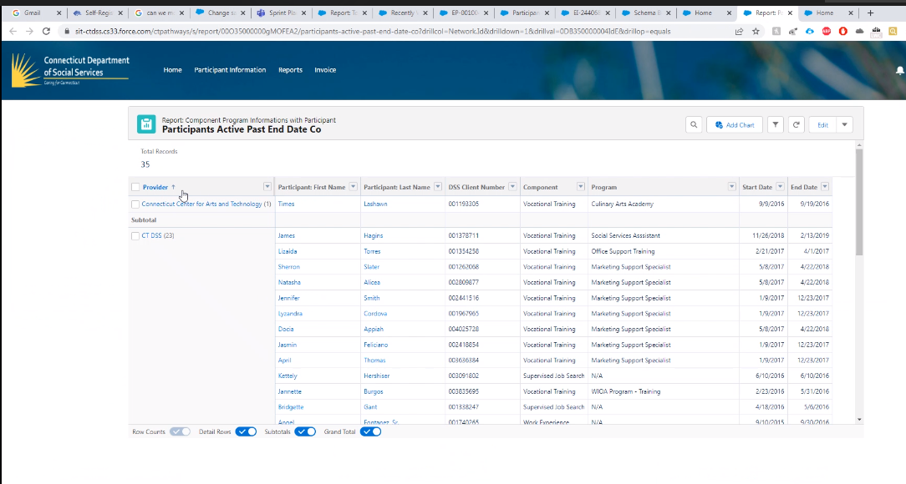

Rarely need to touch Reports or Dashboards

Component = type of assistance

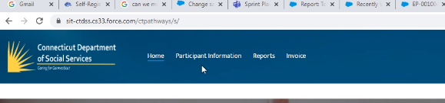

Invoice is a Module

Participant Information:

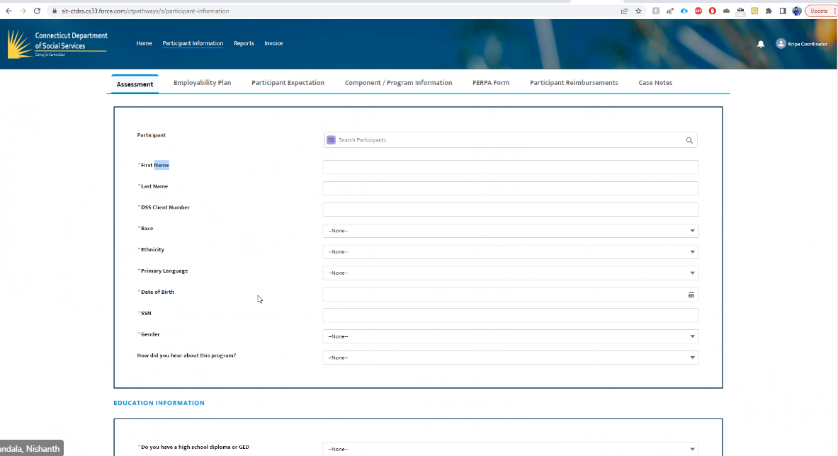

Process:

1. Search to see if they exist already
2. System will find all eligibility records based on the DSS Client number (daily job)
3. Save & Next
4. Employability Plan: Enter plans (employment type, plan, action plan, barriers…)
5. Form…
6. Component info:

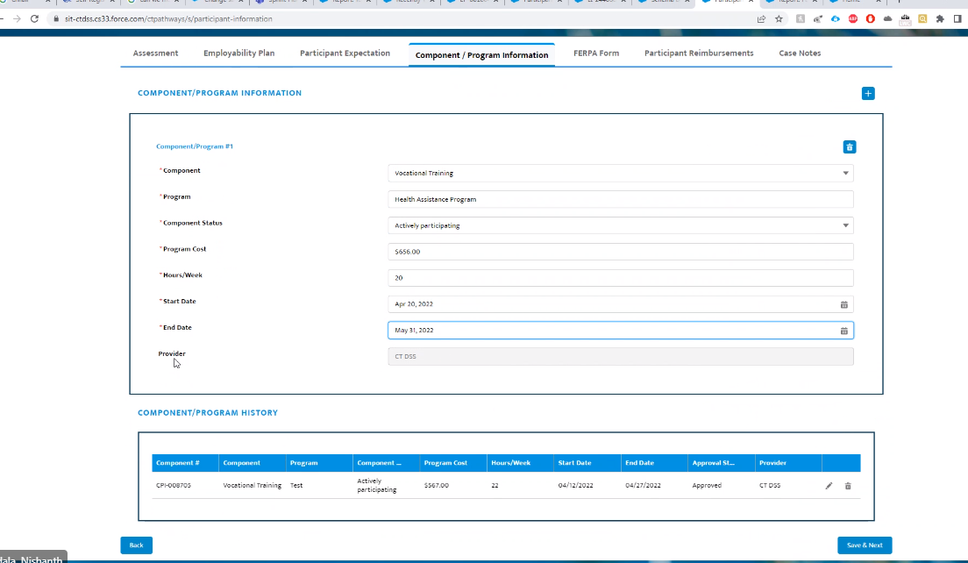

1. Ferpa – consent to obtain education records

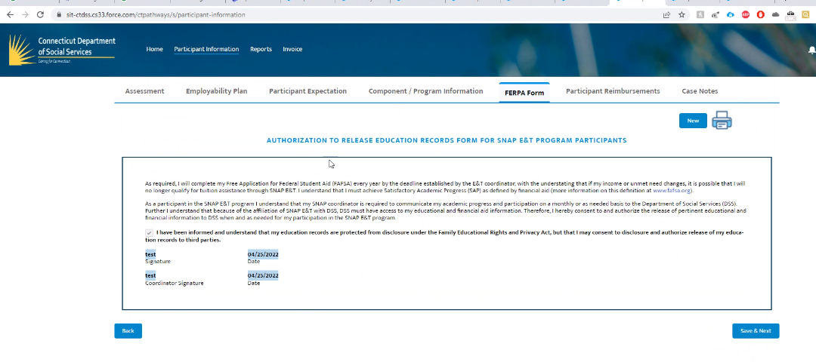

1. Program should be free, but if participant has expenses like books, the college will get reimbursed
2. Last page if for case notes

Pending Change:

Currently – can only enter 1 component at a time

Desired: Ability to enter multiple components at a time

We create Ad-Hoc reports for the business:

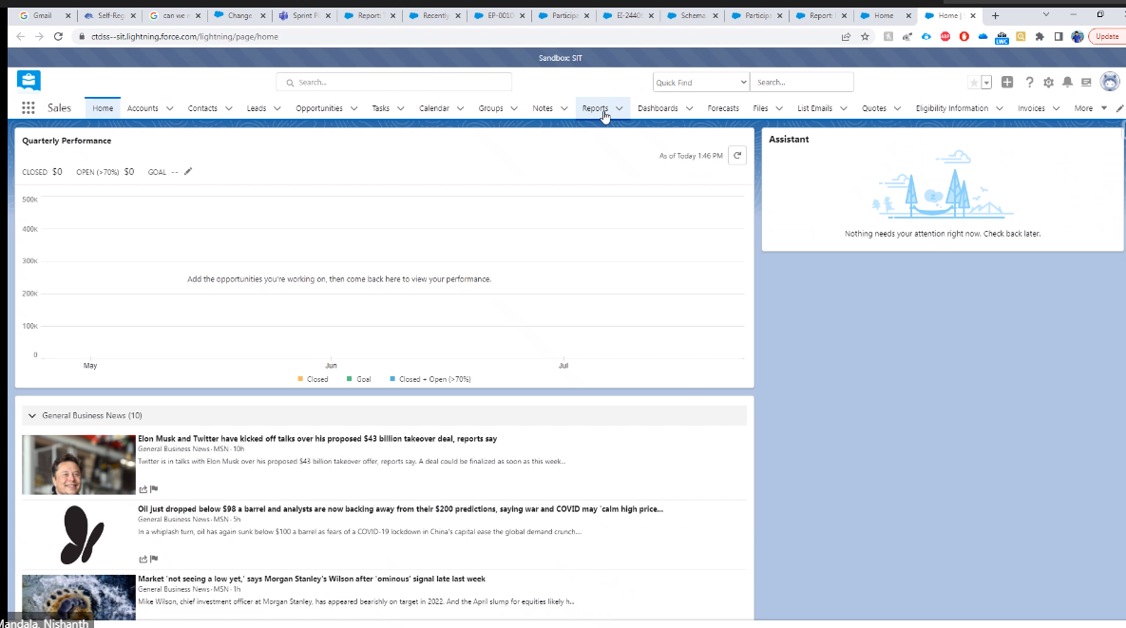

Reports tab

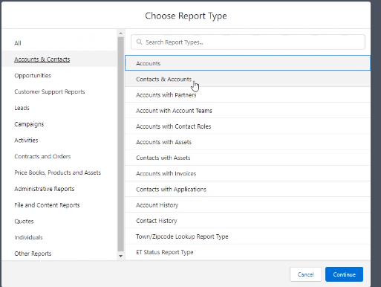

Select the object that you want to report on

Edit the filters

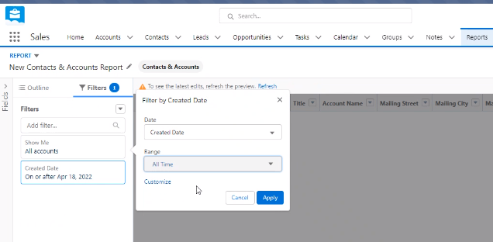

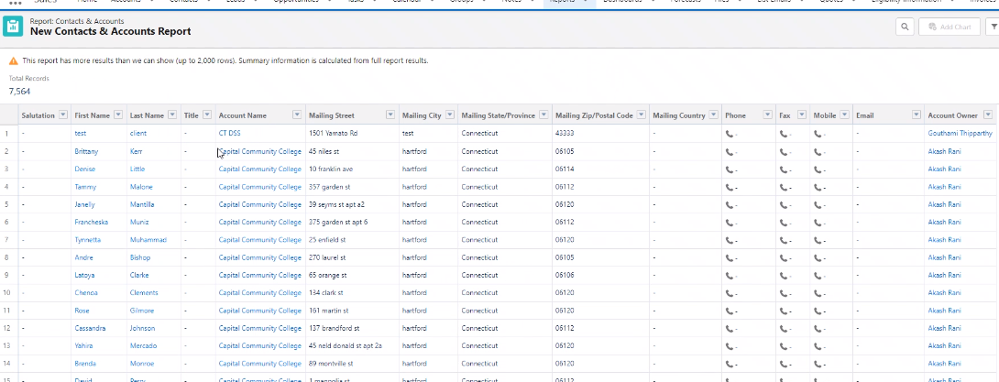

Reports can be exported

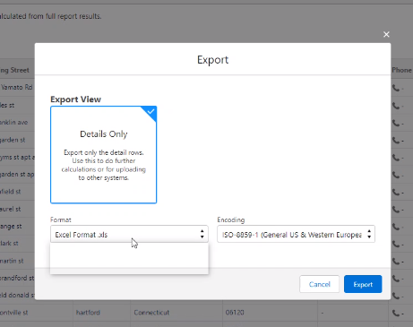

List participants by college

Group by Account Name:

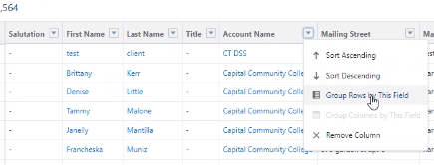

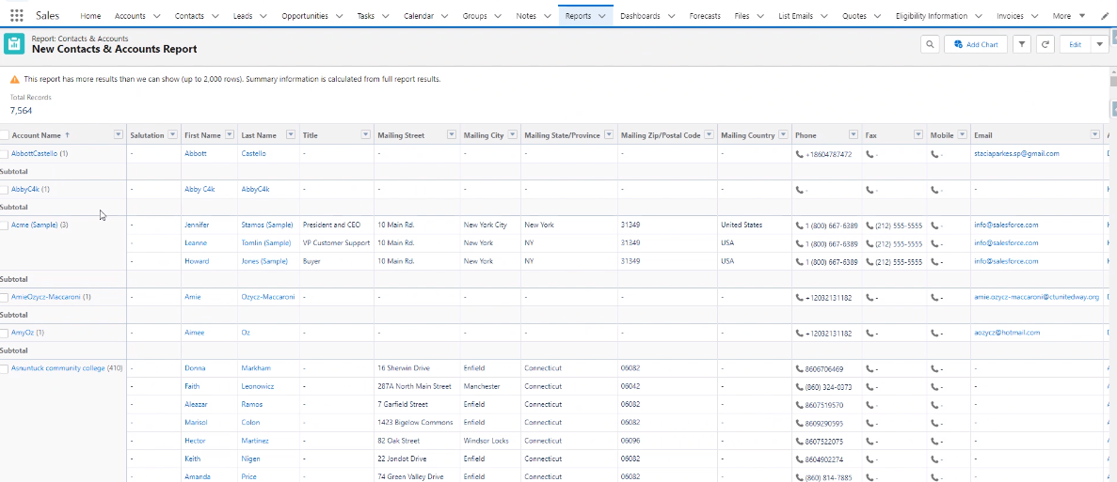

Power User can access reports

Coordinators can access predefined reports

If you put reports in this folder it will be visible to Coordinators

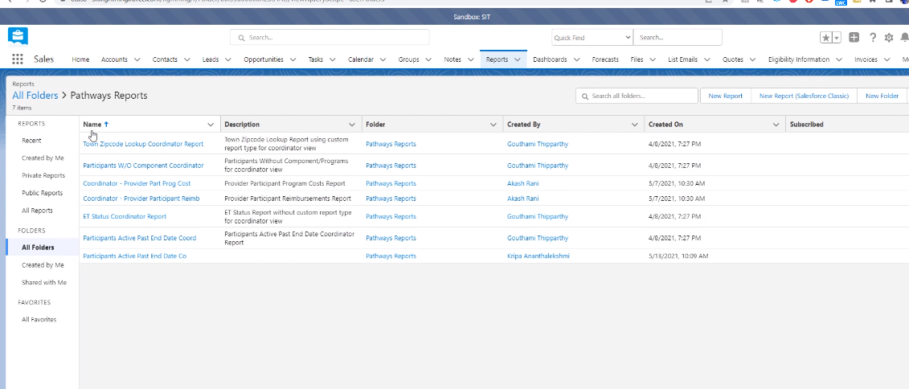

Some users are Pathways Admins (Jenna and Rob)

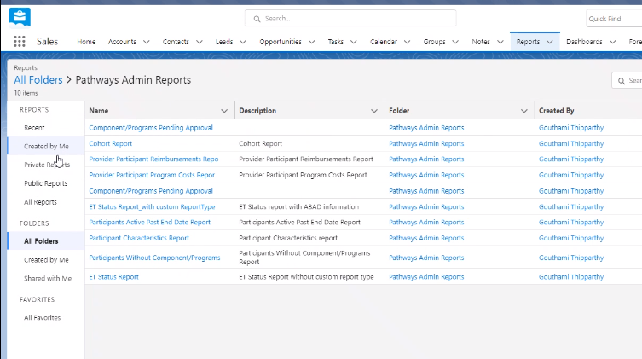

**Business Rules:**

Only 1 for this app

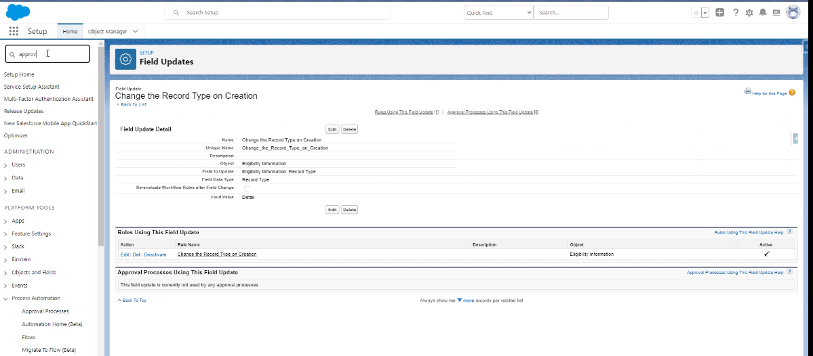

Batch runs in External system – it is a java component gets data from Impact. Is this similar to LIHEAP job that Subu wrote?

Records from 31st added on 1st (next day)

Below is a trigger takes the flat file from the batch to load our eligibility table (I think the batch job triggers this to run using a CLI command)

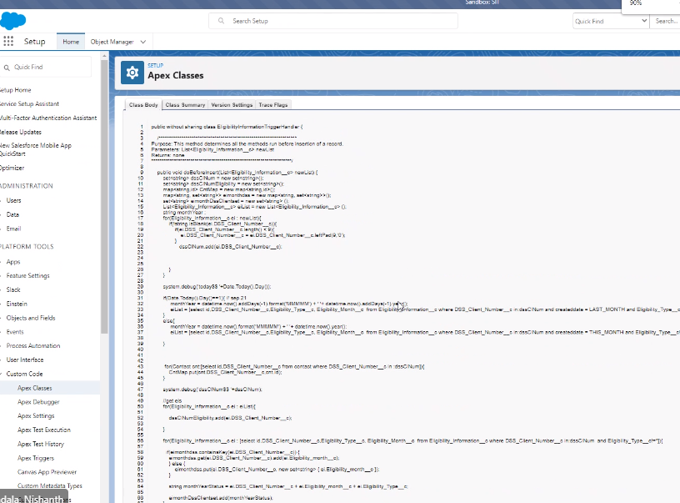

Known issue:

Same person could appear twice for same month. Coordinator needs to remove duplicates

Salesforce does not have a code review tool

Deployment tool – code compare options

Object > Field > Where is this used?

Security:

Profiles:

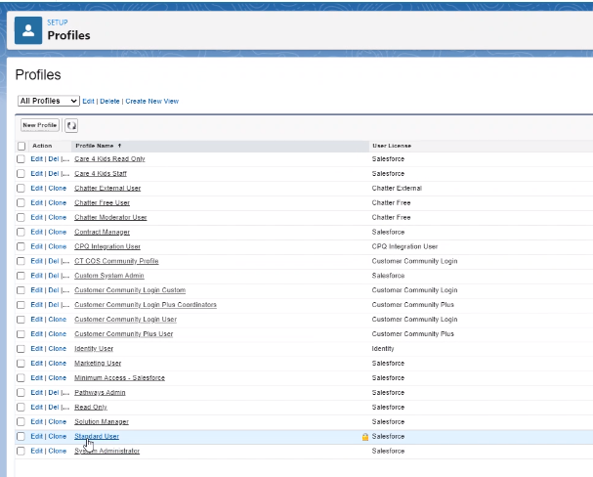

System administrator = Power User

Pathways Admin – Jenn, ?, ?

Customer community plus = coordinator

**Q & A**

UI is Aura

To see communities:

Setup > search sites select All Sites

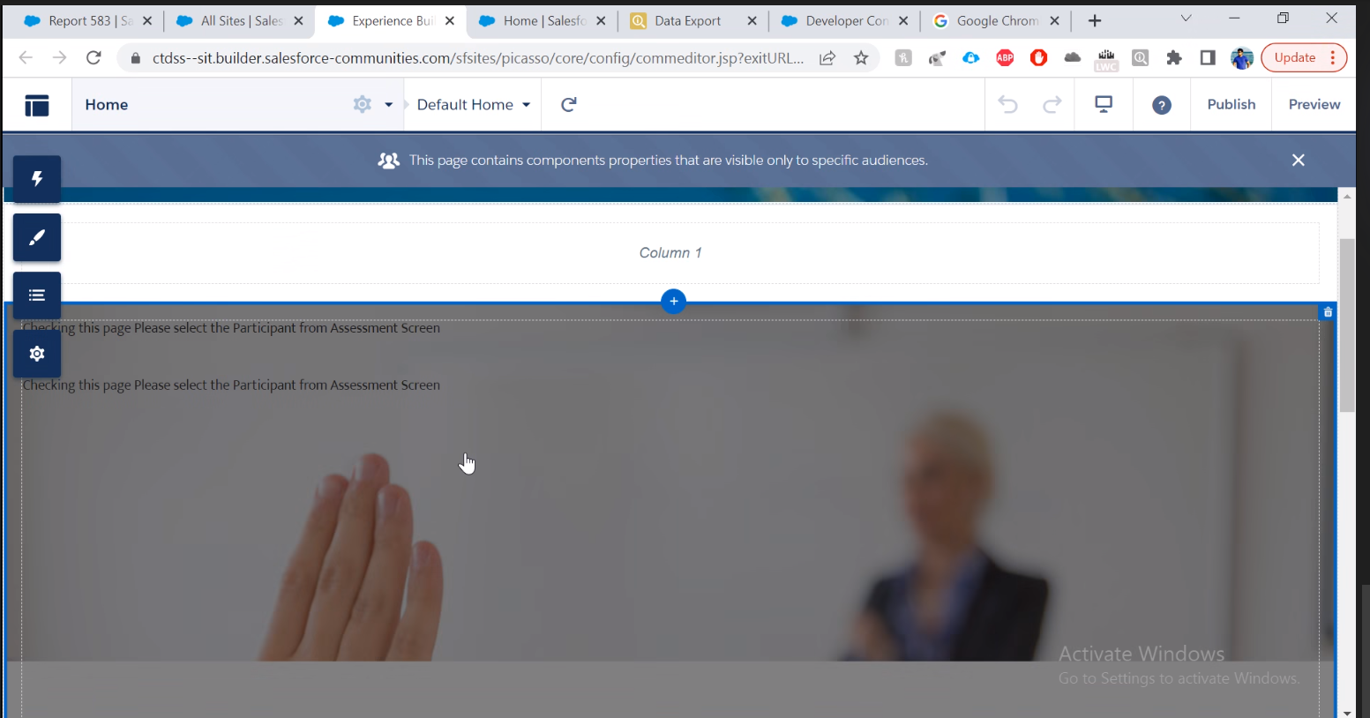

Click here to find aura components

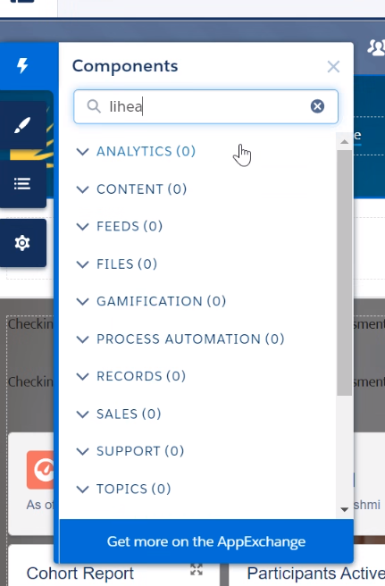

Publish them here:

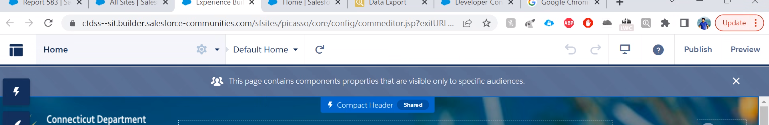

Participant Information is aura

Invoice is aura

Reports is OOB

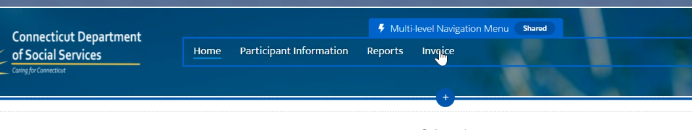

Reports limitation:

Can’t join many tables using standard report

Can’t add button for download